**Software Requirement Specification**

***Insurance Management - POC***

Document Number: INC-MS-1056

Document Version: 0.4

|  |
| --- |
|  |
|  |

*Proprietary & Confidential*

**Copyright 2016 - 2017 INCEDO INC**. All Rights Reserved. No part of this document may be reproduced, stored in a retrieval system, distributed or transmitted, in any form, or by any means, electronic or otherwise, including photocopying, reprinting, or recording, for any purpose, without the express prior written permission of Incedo Inc.

**REQUESTS** For information requests or for obtaining permission for the use of this work, please submit a written request to: Marketing and Communications, Incedo Inc, Plot No. 248 Udyog Vihar, Phase IV, Gurgaon - 122015. Email: communications@incedoinc.com

**Document Revision History**

|  |  |  |  |  |  |
| --- | --- | --- | --- | --- | --- |
| **S. NO** | **VERSION** | **DATE** | **AUTHOR** | **APPROVAL BY** | **REMARKS** |
| 1 | 0.1 | 9-Oct-2017 | Sumit Jain |  | First Draft |
| 2 | 0.2 | 9-Oct-2017 | Sumit Jain |  | Added Request and Response Forms |
| 3 | 0.3 | 10-Oct-2017 | Tajinder Singh |  | Updated some sections |
| 4 | 0.4 | 10-Oct-2017 | Sumit Jain |  | Added Technology Stack |
|  |  |  |  |  |  |

Table of Contents

1. Introduction 4

2. Purpose 4

3. Audience 4

4. Project Scope 4

5. Specific Requirements 4

6. Acronyms & Abbreviations 6

7. References 6

# 

# 

# Introduction

This document provides all information of requirements for the Insurance Policy Management application, which will be used by the users to purchase/select the suitable policies for them.

# Purpose

Insurance Management provides a one stop solution where customer can see what policy best suits them as per their requirements, policy suggestions as per the customer eligibility, purchase the policy online, online premium payments and manage all purchased policies at any point of time.

# Audience

1. Anand Kumar (Sponsor)
2. Tajinder Singh (Project Manager)
3. Rajul Shukla (Developer)
4. Dishant Anand (Developer)
5. Sumit Jain (QA)

# Project Scope

The development of this POC application will be completed in three phases which are explained in detail in section 7.

This application will be an end to end policy management system where-in user can check, buy, service and opt for new schemes as per their criteria. Also, user can do online premium payments as well from his/her user accounts.

The POC will be build using micro services architecture and all the components will be loosely coupled with each other and should be deployed separately;

# Specific Requirements

## Phase 1:

1. User will fill the mandatory details on the UI, policy with premium amount and other details.
2. The above policy will be shown as per the criteria which will be calculated according to the data provided by customer
3. An e-mail will be sent to customer with the estimations and policy details on the e-mail provided
4. User should be able to see all the policies and their details he has selected earlier

**Request Form:**

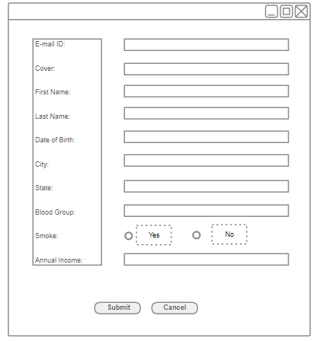

**Response:**

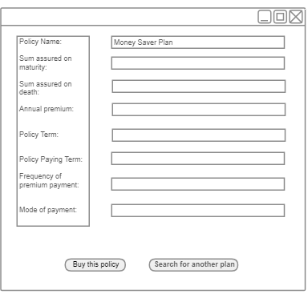

## Phase 2:

1. Customer will be suggested more policies and schemes as per the information provided when customer visits for first time to choose policy
2. Online premium payment facility
3. Premium payment reminders

## Phase 3:

1. Management of enrolled policies
2. Chat bots for service requests

# Technology Stack

Below are the technologies that will be used for building the POC

## NetFlix ZUUL - API gateway, Load balancer

## NetFlix Eureka - Service registry

## NetFlix Eureka Client - Service registry client

## Hystrix - Circuit breaker

## NetFlix Ribbon - Load balancer

## JBoss Drools - Rule engine

## Apache Kafka - message broker

## Feign - REST client

## Spring Boot - Application Famework

## Spring REST API

## Spring Data JPA - Application Famework

## Hiberbnate - ORM (Object relational mapping tool)

## Jenkins - CI Tool

## Sonarqube - code coverage, quality

## JUnit - unit test case framework

## Powermock - test cases libraries

## Mockito - test cases libraries

## Docker - Deployment container

## Kubernates - Deployment container management

## MySQL - DB

## Maven - Build Management

## Git - Repository

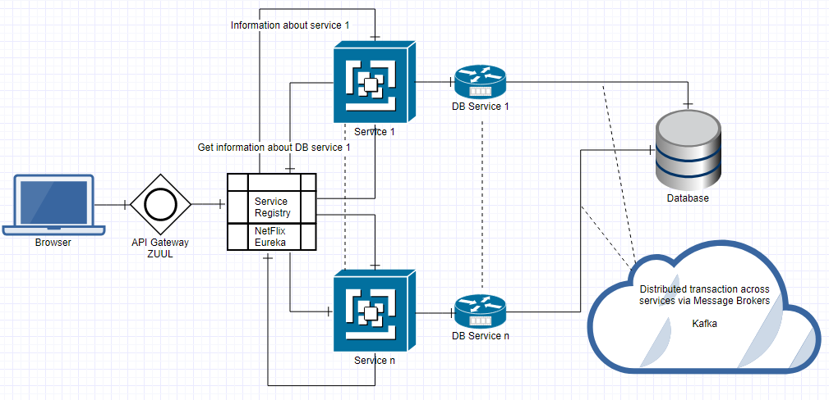

# Acronyms & Abbreviations

IMS – Insurance Management System

POC – Proof of Concept

# References

TBD